**Ipv4 – No Server**

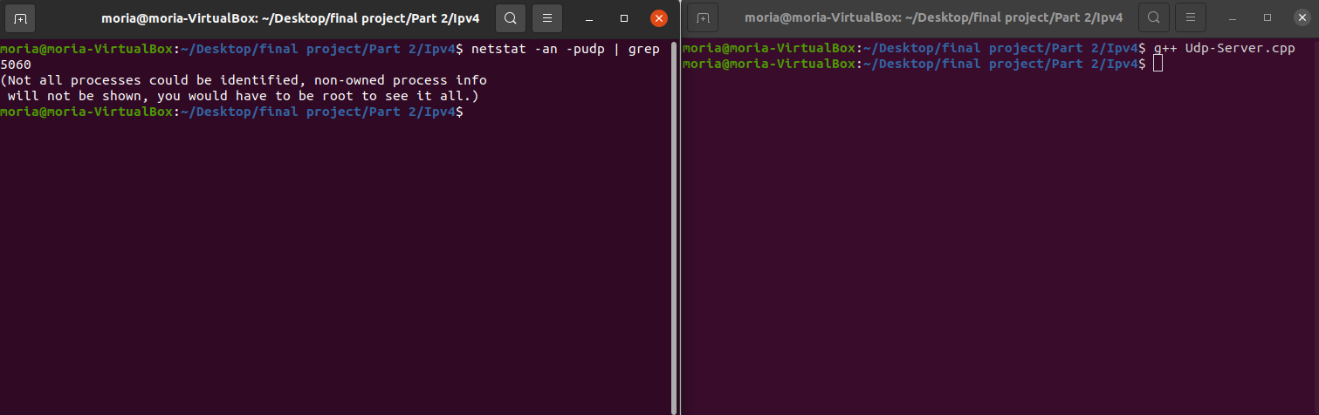

**Ipv4 – Run Server (Port 5060)**

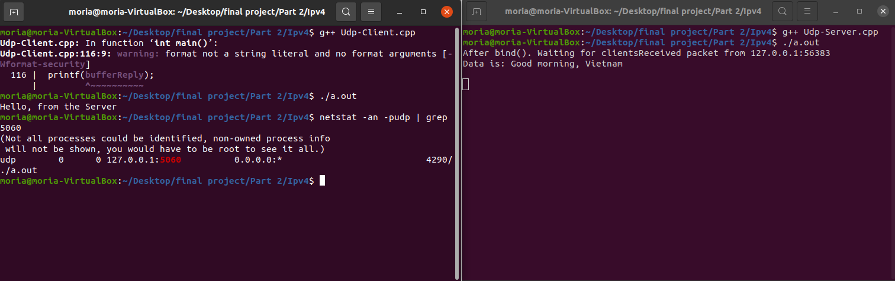

**Ipv6 – No Server**

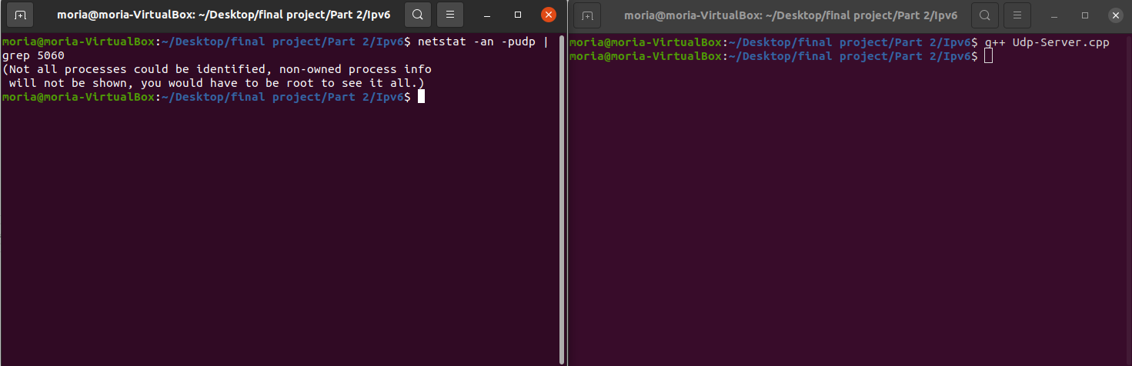

**Ipv6 – Run Server (Port 5060)**

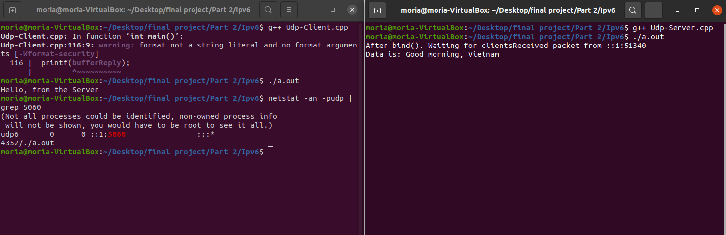

**Wireshark – Ipv4:**

Client to Server:

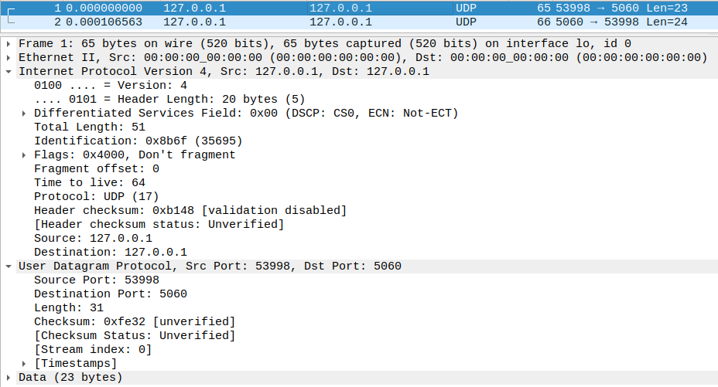

Server to Client:

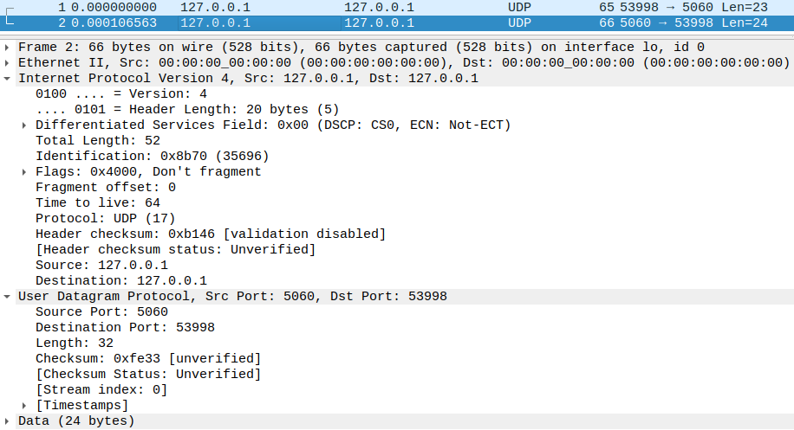

**Wireshark – Ipv6:**

Client to Server:

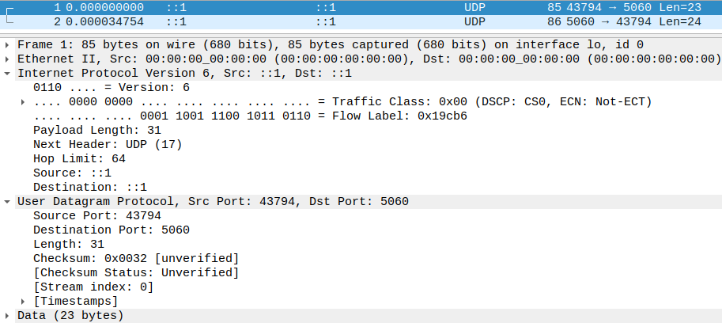

Server to Client:

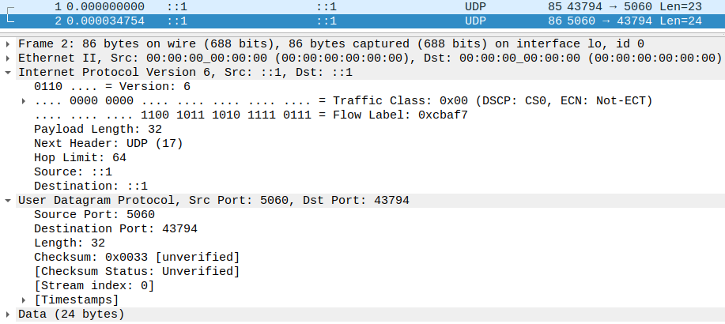

**Main difference between IPv4 and IPv6 headers:**

**The source and destination addresses of IPv4 header are 32 bit long while the source and destination addresses of IPv6 header are 128 bits long.**